Come Join Us!
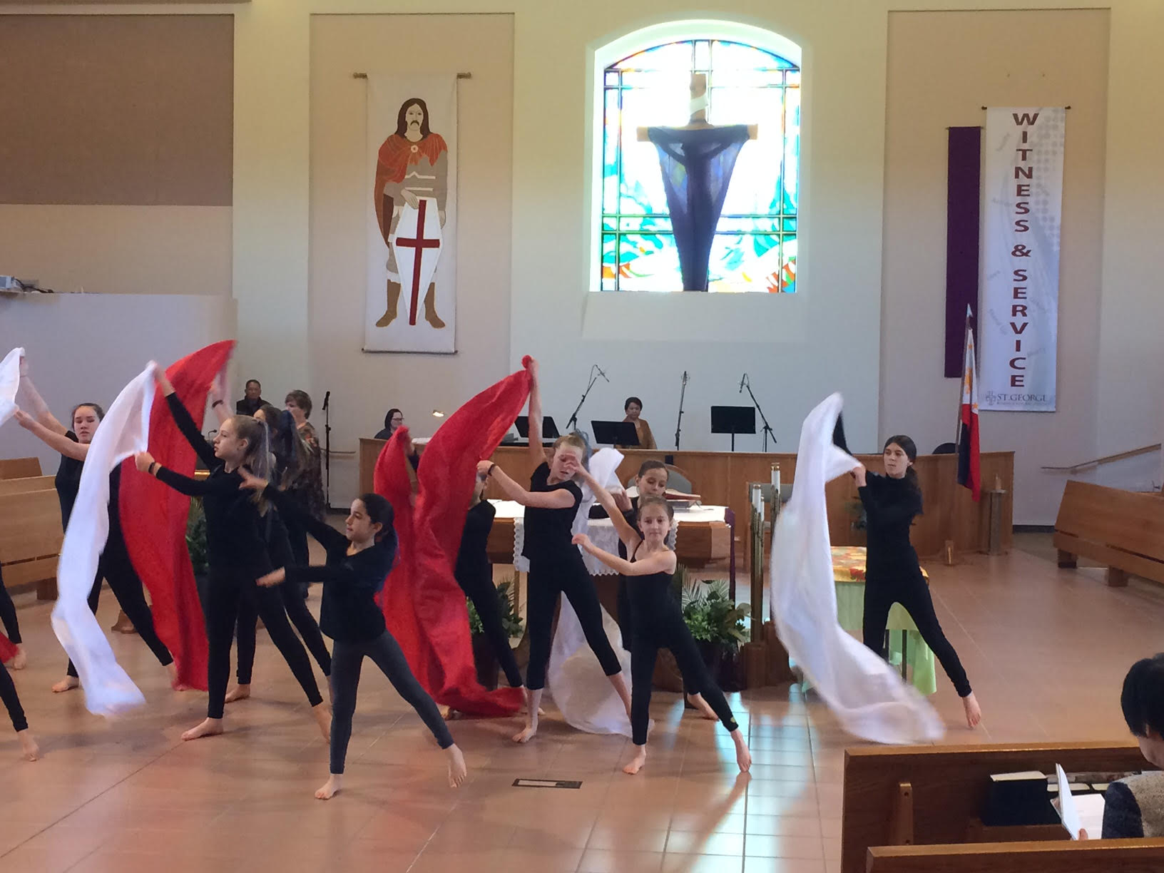
World Day of Prayer
Friday, March 3, 2023
11:00 a.m. – 3:00 p.m.
Any Parish Hall

Come join our intergenerational activities to help us join hearts, minds, bodies and souls in prayer. There should be something for everyone. Volunteers are still needed!

