About Us
We are all sisters in Christ! Here at Any Parish Council, we offer you a chance to join in the national organization of Catholic sisters known as the Catholic Women’s League. Come share your faith, fellowship, and friendship with likeminded women!
Meet the Team
Jane Smith
Parish President

Mary Jones
Membership Chairperson

Molly Abrams
Secretary
The Catholic Women’s League of Canada calls its members to grow in faith, and to witness to the love of God through ministry and service.

Get in Touch!
Any Parish Council CWL
123 Main Street
Anytown, BC V2C 6M1

anyparishcwl@gmail.com
(123) 456-7890
Any Parish Council
Catholic Women’s League
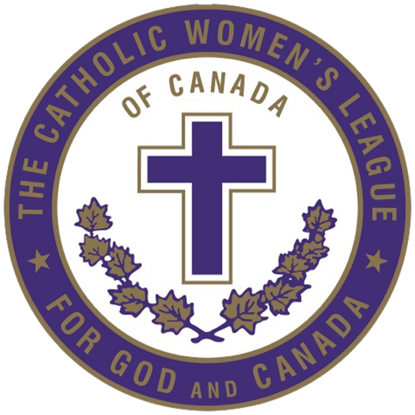
Volunteers Needed
- St. Vincent de Paul Society needs volunteers in its thrift store and breakfast program. Please reach out via svdp@anymail.com
- Youth group needs chaperones! Please see Maryanne after Sunday mass.
- Knights of Columbus need assistance putting together Easter hampers for shut-in seniors. Please reach out to John at (123) 456-1234 or john@knightmail.com
- Retirement Village is looking for families to come and visit at tea time! Can you spare a day?

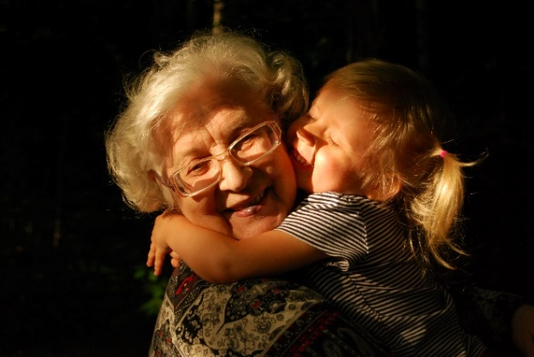

2022 Schedule
March 2022
Come get a prayer card for a child receiving their sacrament this year!

2 – Ash Wednesday
5 – General Meeting at 10:00 a.m.
13 – We are leading the rosary after mass – would you like to help?
19 – Executive Meeting
19-27 Tea Fundraiser

April 2022
Come get a prayer card for a child receiving their sacrament this year!

2 – General Meeting at 10:00 a.m.
15 – Good Friday
17 – Easter Sunday
23 – Easter Season visit to seniors! Sign up to be a visitor or to host visitors!
30 – Executive Meeting
Pinning Ceremony coming in May!
Please congratulate these members and invite your family to help us celebrate on May 8th at the 11:00 a.m. mass!

5 Years
- Jane Doe
- Lilly Jahn
- Susan Johnson
- Mary Smith

10 Years
- Jessica Martin

25 Years
- Cathy Jones

40 Years
- Margaret Abrams

