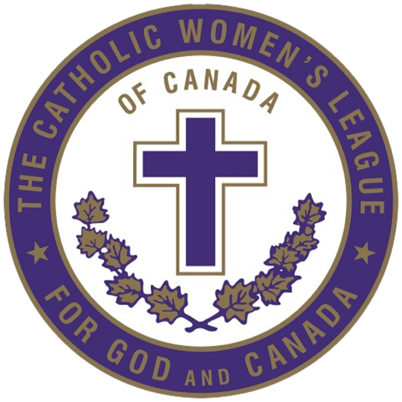  Future Member |  | New Member |  | Long Standing Member
New Mom |  | New to Parish |  | Visiting the Parish

