

[YOUR PARISH] CWL NEWSLETTER

Issue MM/YYYY



WELCOME!

Perhaps include a few words from the editor encouraging members to provide input and feedback to the newsletter.

Consider explaining why the council is starting a newsletter or changing the format.

Do any of your members require a hard copy? How can they obtain one?

INSPIRATIONAL STORY/SCRIPTURE PASSAGE

Consider including something related to the current liturgical season or perhaps a story of hope, resilience and inspiration.

How about a joke? Members can always use a good laugh!

**IN THIS ISSUE**

[BRIEF DESCRIPTION OF NEWSLETTER CONTENTS]

FROM THE PRESIDENT’S DESK

This section is an opportunity for the council president to share a few words with members.



CONTACT INFO

Include the contact information for the chairperson of communications and president.

IMPORTANT DATES AND REMINDERS

Take the opportunity to remind members about upcoming deadlines—for example, membership dues, retreat dates, meeting dates, convention dates, etc.

NEWS TO SHARE

Consider including information the council has received to share from the diocesan president. Does national council have a workshop or retreat that should be highlighted?

QUICK LINKS

Perhaps include a link for the diocesan council, the national website or links that are important to current events.

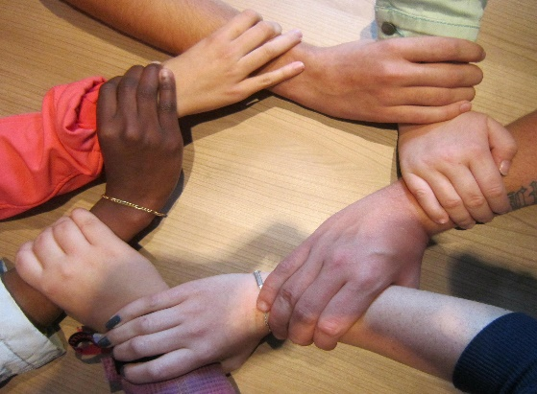

MISSION STATEMENT

The Catholic Women’s League of Canada calls its   
members to grow in faith,   
and to witness to the love   
of God through ministry   
and service.

SOCIAL JUSTICE

This section highlights the social justice projects or events that the council supports.

Does the council need members to donate particular items? For example, personal hygiene items for a local shelter or warm socks and blankets for the homeless. Where should the items be dropped off, and who is in charge if someone has questions?

Does the council need to put out a call for volunteers? Be sure to explain what is expected from the volunteers and what time commitment is required.

FAITH

In this section, share what the council is doing related to the pillar of faith. For example, is the council hosting any retreats or reflections? Is the council hosting a faith study?

This is an opportunity to invite members to an upcoming faith event. Are volunteers needed to help support the event?

The chairperson of spiritual development would be instrumental in submitting contributions for this section.

GRATITUDE CORNER

Please take the opportunity to thank people for their service. Perhaps there is a quieter member that does invaluable work—everyone likes to be thanked!

SERVICE

What service opportunities has the council been involved with at the parish and community levels?

Are there upcoming projects that require volunteers? Be sure to share what is expected of volunteers and the time commitment expectations.

[INFORMATIVE/EDUCATIONAL BLURB]

Suggestions include how to write to members of parliament, information on writing resolutions or information about a current social justice issue.

MEMBER SPOTLIGHT

Has a member has received an award? Share the news! This section is a “rah-rah” opportunity to showcase council members.

Or share the story of a new executive member. Many people like to hear a member’s CWL story—what drew her to the League and her experiences since joining the CWL.

Consider including members from different cultures and ages.



NEWSLETTER CONTRIBUTIONS

Please submit newsletter contributions to XXXX by the XXX of the month and we will do our best to incorporate your contribution.

YOUR CREATIVE IDEAS!

Perhaps a member recently attended a convention and wants to share her story?

Many members often attend convention and come back excited and energized, wanting to contribute more to their council.

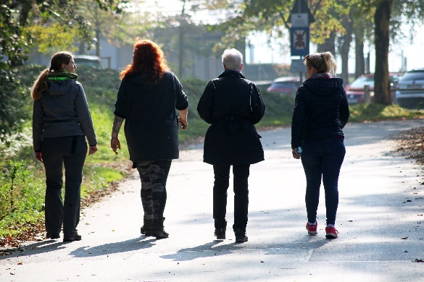

SAINT CORNER

Perhaps the chairperson of spiritual development can help with this section by highlighting a saint for the month. Include information such as the feast day and other important facts here.

MESSAGE FROM FR. xxx

One suggestion for this section is to ask the council’s spiritual advisor for a newsletter contribution. To make it easier for him, consider asking him a question that he could write about. For example, if it is Lent, perhaps ask him to share how to make the Lenten season meaningful and prayerful.

The spiritual advisor may not contribute to each newsletter, so please refer to the suggestions page for other ideas to put in this section.



WHAT’S NEW!

Is there exciting news to share about a member or the council? For example, has a member recently had a baby or become a grandparent? Is a member celebrating a milestone anniversary with her spouse? Try to highlight members of all cultures and ages.

Or, perhaps use this space to welcome new members that have recently joined the council. Has the council started the Companionship Program? Share what is happening with it here!

HAPPY BIRTHDAY

Consider wishing members a happy birthday in this corner by listing the members with birthdays in that particular month(s).

For privacy reasons, actual birthdates should not be shared.

COUNCIL UPDATES

Consider using this space to highlight and showcase what the council has done to accommodate the cultural needs of members.

Are there some members who have mobility issues or have auditory, language or visual needs (large print handouts would be helpful)? Share what steps the council has made to accommodate so that perhaps more members would feel more welcome to attend.